Faces of Emotion:

A Global History
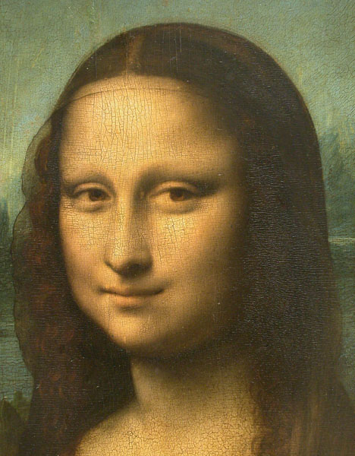
Informal name: ‘Global Faces Project’

Website name: GlobalFaces.info (we own this domain)

Researchers and Advisors

Researchers: Paul James (RMIT), Stephanie Trigg (University of Melbourne), Liam Magee (RMIT)
Website designer: Steven Harris
Education Officer: Vikki Leone
Research Administrators: Melissa Postma (RMIT); Jessie Scott (University of Melbourne)
Advisory Council: TBC (see other notes)

Project Description

Emotions can be described textually. They can be performed and projected. They can be painted, illustrated and drawn. And they can have meaning beyond physical representation. However, for all possibilities of configuring emotions, the locus for both projecting and representing emotions is the human face. Despite this centrality of the face in the history of emotions, and despite some studies of the indexical representation of facial features and the way they express emotions, there has been no substantial history of the patterns of facial representation and the changing ways in which the face mediates human emotions as a means of studying differences between present and past. There are some obvious shifts in the patterns of representation from the individualization of faces across the medieval to contemporary period to the electronic hybridization of faces over the last two decades. However, tracing those shifts, and understanding what they mean for the history of emotions, is complicated and first requires some basic documentation.

If the past continues to shape the present, what are we to make of the National Geographic’s composite image of ‘the world’s most typical person’ created from combining 190,000 photographs of faces? The face is quite particular—a 28-year-old Han Chinese man—but it is also, expressionless, global-generic, computer-generated and highly pixelated. More typically found in advertisements, the global face often takes the form of an androgynous Eurasian with an enigmatic Mona Lisa-like expression representing the diversity of the global community. The face of Benetton generated in 2000, for example, was made up of a sociologically-calculated Eurasian mix of the world’s population to form an Every Woman with a half smile. In parallel, the global ‘Face of Tomorrow’ comes in male and female, looks Euro-South Asian and is neither happy nor sad.

The project is thus one of exploring continuities and discontinuities. In relation to contextualizing the emotional meaning of faces, we intend in the first instance to set up an image-text database; tentatively entitled ‘Five-Hundred Faces that Represent the Human Condition’. This database would firstly collect images of the face, predominantly from 1100 to 1800 (but also before and after) and research the contextualizing textual material that helps frame how that face has been understood across the period 1100 to the present. For example, since Leonardo da Vinci painted Mona Lisa in the early sixteenth century, numerous interpretations of what Lisa del Giocondo is feeling and thinking have been written. The database would link those textual interpretations to the image as a searchable bibliometric repository. It would be tagged in such a way as to allow comparison across different time-periods, countries (using a modern-equivalence categorization), language, gender, age, vocation, cultural-ethnic affiliation, and the genre of writing in which the text occurs.

Secondly, once a basic set of images-with-text have been established, we would open the website to contributions from across the globe on a networked ‘area’ linked to FaceBook called ‘FaceTime’. The space would be open. Any registered person would be able to see their own voting patterns, and on their facebook page lodge a new image or comment on an existing image on our website. These comments (requiring a basic registration process), would themselves be archived and tagged according to the same categories as above, elicited in the registration process.
On our website, registered contributors would be asked to tag faces in relation to a taxonomy of terms for emotion and/or comment on what they think the face is expressing. The taxonomy would be adapted from a series of taxonomies across history: 1. Aristotle’s 2. Thomas Aquinas’s thirteenth-century taxonomy; 2. the classic thesaurus by Peter Mark Roget writing just after 1800; the online Roget’s Thesaurus. We would use a voting process to enhance public interest in participating—participants would be invited to vote once on a number of questions (electronically verified for each email address) for the face that they think is most important in representing a particular aspect of the human condition. The voting would be anonymous but publicly registered according to the registered biometric information, with ‘word cloud’ representations of current voting patterns.

This aspect of the project will also have a local dimension, as we envisage developing the site in such a way that it can be taken into schools to encourage students to respond, to comment, and to upload their own photographs and images. Students would be encouraged to meditate on historical and cultural difference, and also to explore the rich semantic possibilities of the thesaurus, and the taxonomy of emotions.

Thirdly, over the long-term, the work of building of the database as part of a global mapping of the faces of emotion would be used to write a monograph called The Face Book: A Global History of Figures of Emotion (Stephanie Trigg and Paul James).

Time Line: January 2012–December 2014

Milestone | Brief Description of Work to be Done | Date to be Completed | Status
Team meeting to develop concept | Initial extended meeting of CIs to develop project brief | January | Done
Prospectus v1 | Develop the first stage of the project through outlining the structure of the project and guiding rationale | April 2012 | Done
Team meeting to refine concept | Team meetings to develop project | February | Done
Prospectus v2 | Develop time-line and outline budget | April 2012 | In process
Global Advisory Council | Appoint an advisory council to the project to referee the process of choosing names and images. | June 2012 | In process
Literature Review | Review of key emotion taxonomies (Myers Briggs, Big 5 etc.) | December 2012 | In process
Website prototype | Development of image database and administrative interface  Initial user interface for image navigation and selection  Loading of initial image set into database  Website wireframe – structure and key user interface elements in place | December 2012 | In process
Stage 1. Global Faces website prototype | Initial draft of Global Faces website – key administrative and navigation components in place | December 2012 | In process
Ethics application | Development and approval of ethics application | June 2013 | Not yet commenced
Image selection | Final selection of key facial images, categories, accompanying metadata in place | October 2013 | Not yet commenced
Website development | Development of user interaction tools (image surveys, semantic tagging)  Construction of multi-layered emotion digital taxonomy (with cross-references to standard taxonomies)  Data structures and queries for surveys, tagging  Functional website (beta) | October 2013 | Not yet commenced
Website Pilot | Evaluation of Global Faces website with small cohort of users | December 2013 | Not yet commenced
Stage 2. Completion of Global Faces website | Functional complete website and system in place | December 2013
Website Launch | Promotion of website through social media  Ongoing monitoring of system to ensure valid data collection | February 2014
Collect and analyse data | Collate data from website data instruments (surveys, tagging system)  Analysis of data using scripts, SPSS | June 2014
Prepare publications | Write up of data findings  Publication of papers | December 2014 | Not yet commenced
Stage 3. Project completion |  | December 2014 | Not yet commenced

Budget
Item | Work to be done | Time Frame | Amount
Development of image database | Security framework  Image upload facilities  Image metadata fields | 3 months | $5,000
Image presentation tool | Generic user interface for rendering randomly generated large sets of images (thumbnails), and high resolution versions | 3 months | $5,000
Literature review of emotion taxonomies | Review existing psychometric systems (Myers-Briggs, Big 5, IPIP, etc.) | 3 months | $5,000
Initial database of faces | Compile initial set of 500 face images (‘Faces of Humanity’, ‘Faces of Emotion’, etc.) | 1 month | $3,000
Website wireframe | Develop initial website structure | 1 month | $2,000
Total for 2012 |  |  | $20,000, less carryover
Carried over to 2013 |  |  | Still to be determined
Initial emotion taxonomy | Develop consolidated emotion taxonomy, based on literature review | 3 months | $5,000
Semantic cloud tool | Develop tagging tool for applying labels to facial images from the emotion taxonomy | 1 month | $2,000
Image survey tool | Develop different surveys corresponding to distinct facial systems | 2 months | $3,000
Data analytics | Build queries, scripts for aggregating data collected from different surveys | 3 months | $5,000
Website (beta version) | Develop website with complete functional components (‘Faces of Humanity’, ‘Faces of Emotion’, etc.) | 1 month | $2,000
Global Faces pilot | Pilot website | 2 month | $3,000
Total for 2013 |  |  | $20,000, plus carryover
Final website deployment | Incorporate feedback from pilot  Test and launch website | 2 months | $3,000
Data collection & analysis | Promote website through social media (FaceBook, Twitter, Google+)  Collate data from different survey instruments (emotional responses, semantic tagging)  Consolidate and analyse data patterns | 4 months | $7,000
Publication(s) | Write-up data collection for journals, conferences  (3 papers) | 6 months | $10,000
Total for 2013 |  |  | $20,000

Website Structure and Considerations

• Consider making the platform ‘open source’ so others could work on it.
• Make sure that the platform is customized for i-phone deliverability.

Global Faces: Figures of Emotion
1. Faces of Humanity
2. Faces of Emotion
3. Faces of History
4. Faces of Encounter
5. Faces of Reconciliation
6. Clouds of Emotion
7. About Us
8. Contact Us
9. Donations

Page 1. Faces of Humanity

One-hundred faces from across the globe and across history that represent the human condition

On this page and its subpages we would have images of 100 faces across human history selected across a number of criteria.

Criteria for deciding on the 100 faces
• Made a significant contribution as recognized by a particular cultural/political/economic/ecological field or traditional; and/or
• Is iconic in a particular cultural/political/economic/ecological tradition; and/or
• Represents an aspect of the human condition (without being individually famous)
—with consideration to the spread across time, place of birth, gender, vocation, religion, etc.

The images would be named; have a cursor-activated official description; and then a click-based subpage. This requires a website with the following technical capabilities:

Capability 1—To have a randomly changing collection of thumbnail photographs with 40–50 on display. The photographs that are used on all the pages need to be held in a database of images.
Capability 2—To upload, store (with restricted, and moderated access) and view (with public access), literary, political, and other published quotes from different sources about each image.
Capability 3—To upload and store (with moderated access) and read (with public access) discussion around each face from registered users.
Capability 4—To upload and store (with administrator rights) documents, essays, etc, in relation to particular faces.
Capability 5—Cursor prompted dates, names and brief description of each face.
Capability 6—Capacity for the face chosen under Question 1 below to become a featured icon when a person enters the page.

Rationale
- Random placement and rolling of images into view has been chosen because we do not want selections to be made with any bias towards a Western orientation towards reading top to bottom and left to right—or towards alternative cultural orientations given different ways of reading.
- 100 was chosen because 1. it is a culturally significant number and 2. it is a large enough number to give a range of faces across human history.

Page-description
• Top
—Banner and then a set of images of faces from different periods of history that revolve through the set at about 2 seconds per view.
• Lefthand 2/3 of the page
—Description of the project
—Description of the process: voting etc.
• Righthand side column 1/3:
—Single-column list of the current top 50 faces (thumbnails) in rank order (composite ranking) that represent the human condition as voted by people around the world in relation to seven questions:

Q1. Whose face is most like your own? (Familiarity)
Linked to Capability 6
Q2. With which person do you most identify? (Identification)
Q3. With whom would you most like to talk about things that matter to you? (Engagement)
Q4. Whose face best expresses how you feel now? (Mutuality)
Q5. Who would best represent you in an imagined global forum? (Representation)
Q6. Who is the most important person in human history? (Power)
Q7. Who would you most like to be? (Being)

• Capability 7—to place a response (vote) in relation to seven questions (no more than one vote for each face in relation to each question above for each person who votes).
• Capability 8—to see how many votes are registered against each face in relation to the seven questions.
Rationale: this becomes a reward for registering and voting on the faces.
• Capability 9—to choose a century and only see the faces from that century
• Capability 10—to choose a country/language/gender/vocation/cultural-ethnic identity and see only the faces from that category.
• Capability 11—to have a networked page linked to FaceBook in which your chosen faces in relation to the seven questions are featured (and can be changed); as well as your own face or other chosen faces expressing various emotions, with the potential to write about the emotions expressed in the chosen faces—either your own or other peoples.
[Do we need FaceBook as a partner in this project?]

NB. Capabilities 2-8 need to be based on a registration process where a person’s following characteristics are recorded:
- country of residence; 2. city of residence; 3. city of birth; 4. first language; 5. gender; 6. age; 7. field of activity or vocation; 8. cultural-ethnic identity
[Should these all be by a drop-down menu of choices?]
Someone cannot see the numbers of votes or categories of voting until they register.

Levels of access:
- Global Face team; 2. Global Advisory Council; 3. Registered users (Academic); 4. Registered users (Public); 5. Open to the all

Draft list only. The Global Advisory Council will suggest and advise on the 100 faces that we finally choose.
Period | Person | Dates | Country (using the modern nation-state equivalence) | City of birth
Pre-0s | Nefertiti  Plato  Buddha (Siddhārtha Gautama)  Confucius | c.1370–c.1330 c.424–c.348  c.563–483  c.551– c.479 | Egypt  Athens  Nepal  China | ?  Greece  Lumbinī  Qufu
0s | Jesus of Nazareth  St Paul of Tarsus | c.0–c.32  c.5–c.57 | Israel/Palestine  Israel/Palestine | Nazareth  Tarsus
100s | Claudius Galen | c.130–c.210 | Turkey | Pergamum
200s | Plotinus | c.204–270 | Greece | Lycopolis
300s | Constantinus Augustus | 272–337 | Turkey | Naissus
400s | Augustine of Hippo | 354–430 | Algeria | Thagaste
500s | Emperor Wen of Sui | 541–604 | China | Chang'an
600s | Muhammad | c.570–c.632 | Saudi Arabia | Mecca
700s | Charlemagne | c.742–c.814 | France | Herstal
800s | Han Yu | c.768–824 | China | Nanyang
900s | Abd-ar-Rahman III | c.889–961 | Spain | Córdoba
1000s | William the Conquerer | c.1028–c1087 | France | Normandy
1100s | Genghis Khan | c1162–1227 | Mongolia | Temujin
1200s | Jalāl ad-Dīn Muḥammad Rūmī  Thomas Aquinas  Marco Polo | c1207–c.1273  c1225–1274  c1254–c1324 | Afghanistan  Italy  Italy | Balkh  Roccasecca  Venice
1300s | Petrarch (Francesco Petrarca)  Geoffrey Chaucer  Christine de Pizan | 1304–1374  c.1343–1400  c.1364–1430 | Italy  England  Italy | Arezzo  London  Venice
1400s | Johannes Gutenberg  Saint Joan of Arc  Leonardo da Vinci  Erasmus (Gerrit Gerritszoon)  Niccolò Machiavelli  Nicolaus Copernicus | c.1398–1468  c. 1412–1431  1452–1519  1466–1536  1469–1527  1473–1543 | Germany  France  Italy  Netherlands  Italy  Poland | Mainz  Domrémy  Vinci  Rotterdam  Florence  Toruń
1500s | Martin Luther  Mona Lisa  Gerardus Mercator  Elizabeth I of England  Tokugawa Ieyasu  William Shakespeare | 1483–1546  c.1503  1512–1594  1533–1603  1542–1616  1564–1616 | Germany  Italy  Belgium  England  Japan  England | Eisleben  Florence  Rupelmonde  Greenwich  Matsudaira Takechiyo  Stratford-upon-Avon
1600s | William Harvey  Rene Decartes | 1578–1657  1596–1650 | England  France | Folkstone  La Haye en Touraine
1700s | Johann Sebastian Bach  Jean-Jacques Rousseau | 1685–1750  1712–1778 | Germany  Switzerland | Eisenach  Geneva
1800s | Napoleon Bonaparte  Ludwig van Beethoven  Charles Darwin  Karl Marx | 1769–1821  1770–1827  1809–1882  1818–1883 | France  Germany  England  Germany | Ajaccio  Bonn  Shrewsbury  Trier
1900s | Mohandas Gandhi  Albert Einstein  Pablo Picasso  Adolf Hitler  Elizabeth II  Bob Dylan | 1869–1948  1879–1955  1881–1973  1889–1945  1926–present  1941–present | India  Germany  Spain  Austria  England  United States | Porbandar  Ulm  Málaga  Ranshofen  London  Duluth
2000s | Tim Berners-Lee  Osama bin Laden  Michael Jackson  Barack Obama  Benetton composite face  National Geographic’s face | 1955–present  1957–2011  1958–2009  1961–present  2000  2010 | England  Saudi Arabia  United States  United States Global  Global | London  Riyadh  Gary  Honolulu

—consider linking all these to Wikipedia biographies.
Page 2. Faces of Emotion (Level 2)

Fifty faces that represent the range of human emotion

On this page we would feature a set of fifty faces representing a range of human emotions. These would be iconic images rather than depictions of known persons (although some faces might be known). They would not necessarily include any of the faces from ‘Page 1’. We will consider some of the classic studies of faces and emotions and perhaps use some of the photos from either other face-emotion research projects using actors or from stills from classic films.

People who register for the website would be asked to link one of more of these faces to between one and seven ‘emotions’ from a taxonomy in the form of a ‘word field’.
—See http://www.tagxedo.com/ google “word cloud” to get a range of programs.

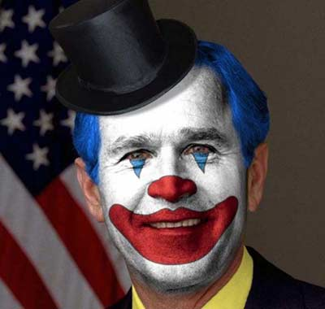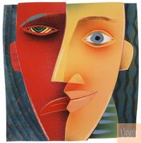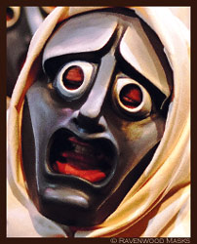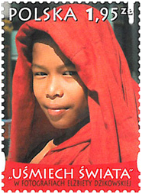

Period | Face | Dates | Country (using the modern nation-state equivalence) | City
 | Clown face
 | Moon face
 | Greek tragedy mask
 | Greek comedy mask
 | Japanese baby horror face
 | Mona Lisa | c1504
Laughing Albert Einstein

Etc. Etc.

• Capability 1—To have a 5 second turnover of faces and randomized placement of faces with tiles fading as you have located them.
• Capability 2—To click on a face in the list and to associate that face with words in a semantic field of emotions (based on our agreed taxonomy of emotions); and for this to be recorded in a database.
• Capability 3—To represent to people who come the website the data, through a semantic cloud, the data that we collect from registered respondents who use ‘Capability 8’.
—Set up a relationship to WordNet (word.net.princeton.edu) There should be a link from each of our words to an on-line set of definitions.
[Do we need alternative sets of words in different languages?]
• Capability 4—To record the strength of various emotions against a multiple-point scale of intensity. (See Appendix 3.) NB. We are, however, moving away from this capability given the difficulty of working out what it would tell us on all but a few emotions. How, for example, can one be ‘moderately’ serene or ‘somewhat’ furious? One possibility is to choose seven iconic emotions (so-called primary emotions) and test these.

- Happiness; 2. Sadness; 3. Anger; 4. Fear; 5. Hope; 6. Love; 7. Disgust
… but this relatively arbitrary and there is not much concordance in the literature on what are the primary emotions.

One possible scale:
1. intensely; 2.moderately; 3.somewhat; 4. not at all

Intensely happy | Moderately happy | Somewhat happy | Not at all happy
Strongly hopeful | Moderately hopeful | Somewhat hopeful | Not at all hopeful
Very angry | Moderately angry | Somewhat angry | Not at all angry
Very annoyed | Moderately annoyed

Another possible scale:
1.very high; 2. high; 3. moderate; 4. low; 5. very low; 6. not all

[For possible later development: Capability 12—to use one’s i-phone through an application to respond each day to a randomly time text message that asks you to record how you are feeling against the fifty faces in our list. A version of this has been done by http://www.mappiness.org.uk/ which electronically records happiness from people’s i-phone through a downloadable app.]

NB. We need ideally to find an existing (well researched) modern schema that actually works or at least approximates a workable model for semantic structuring that we can add to using older taxonomies. This is complicated. There is, for example, no straight-forward list of synonyms and antonyms for emotions. For example, Aquinas describes eleven basic kinds of passions. Crossing good and evil with three different kinds of motion describing the movement of the appetite produces six ‘concupiscible passions’:
love [amor] and hate [odium]
desire [desiderium, concupiscentia] and aversion [fuga]
joy [delectatio] and pain [dolor]
Then four ‘irascible passions’ are produced by multiplying the nature of their objects with the direction of the motions with respect to those objects;
hope [spes]
desperation [desperatio]
fear [timor]
daring [audacia].
To these, Aquinas added the rather special case of anger [ira], which presupposes a concupiscible passion of pain, and is a resolute appetite to remove the present source of pain.

We could set up a list of emotions in a semantic field, though one which is more systematically ordered than the word cloud below: words arranged horizontally, with linking colours, graded by intensity and size.

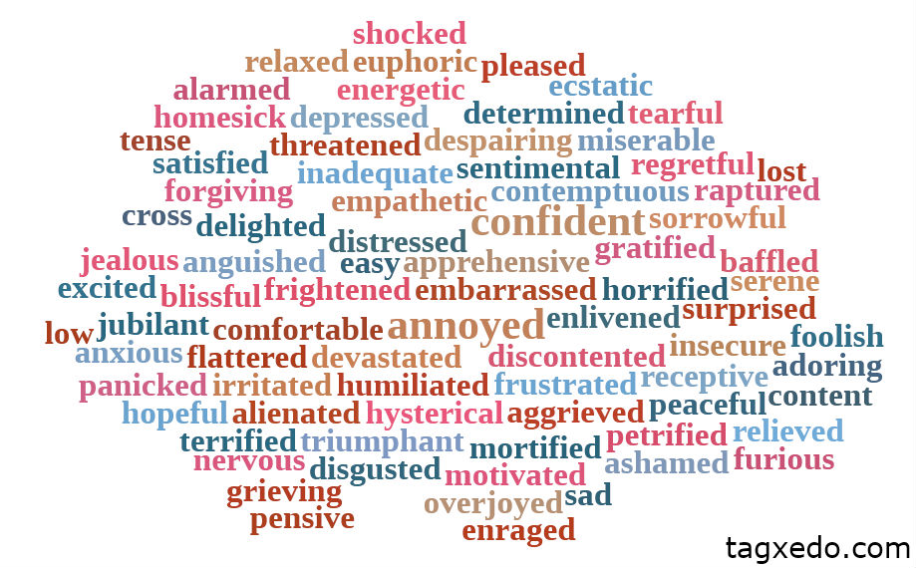
—Think about semantically semi-clustered words, with the possibility of self-chosen colour coding around a series of clusters marked by key concepts.
—Double click to add more words in a cluster

• reference to International Personality Item Pool to the extent that it references emotions. Possible mapping of faces against standard personality types.

Thus we would present people with a conceptual map with interconnected concepts. One option that we could build upon comes from a paper by Christine Storm and Tom Storm called ‘A Taxonomic Study of the Vocabularly of Emotions’ (1987). The virtue of this approach is that simply puts numbers against semantically related groups of concepts. This mitigates the need for a list of primary names for clusters of emotions.

The matrix below, adapted from Storm and Storm (1987)—who had 18 clusters—has 4 by 7 = 28 clusters.
The box below is based on a two-way matrix of positive/negative and engaged/quietist (active/passive does not work). It could be depicted as a ‘Circle of Emotion’ with four domains and seven subdomains in each domain. The version below includes Aquinas’s taxonomy from the thirteenth century, and Parrot’s terms from the twentieth-first century (2000).

Positive / Engaged Positive / Quietist
1. cheerful delectatio delighted ecstatic elated enraptured enthusiastic euphoric exalted happy gay glad joyful rapturous  2. affectionate amor adoring caring empathetic loving proud  3. concupiscentia desiderium desiring horny lustful romantic  4. audacious audacia confident determined hopeful jubilant motivated optimistic strong triumphant vital zealous  5. alert curious excited eager energetic enlivened enthralled exhilerated interested playful thrilled zestful  6. amazed astonished surprised  7. forgiving reconciling sympathetic | 1. blissful calm comfortable content harmonious, peaceful pleased sanguine serene  2. sentimental  3. admiring tender  4. flattered gratified satisfied relieved spes  5. pensive receptive relaxed  6. amused awe-struck relieved wonder-struck  7. reconciled resigned
1. agonized anguished bereft despairing desperate desperatio devastated distressed grieving miserable sad upset  2. aggravated agitated angry bitter cross exasperated enraged furious irate ira irritated livid petulant vengeful wrathful  3. contemptuous disdainful disapproving disgusted hateful hostile loathing odium revolted revulsed scornful spiteful sickened  4. alarmed distressed panicked petrified scared shocked terrified terrorized tormented timor  5. horrified mortified shocked  6. anxious hysterical homesick  7. humiliated envious insulted jealous | 1. blue dejected depressed despairing disappointed discontented dismayed down forlorn gloomy glum grief-struck grouchy grumpy hopeless low melancholic pitiful sorrowful tearful wan weepy woeful  2. aggrieved annoyed frustrated resentful seething  3. disliking fuga reproachful smug  4. afraid fearful frightened hurt threatened trapped  5. anxious apprehensive dolor insecure nervous tense uneasy worried  6. alienated apathetic baffled bewildered bored confused demoralized enervated inadequate isolated lonely lost mixed-up neglected rejected sheepish tired troubled weary  7. ashamed embarrassed foolish guilty regretful remorseful shameful stupid
Negative / Engaged Negative / Quietist

Test of whether the concept belongs in the above table
- Can the concept be used to finish the following sentence? ‘I feel …’; and
- Is the concept an adjective? Can it be used in the following sentence? ‘Looking at that individual’s face I can see that she/he is now …’
- Can it be turned into a noun that is understood as an emotion that somebody feels?

Possible key dimensions:
Valence positive / negative
Activation active / quietist
Power dominant / subordinate
Relational directed / undirected
Relational With interpersonal reference / without interpersonal reference

Other possible dimensions:
Intensity (although this is completely ambiguous textually)
Temporal orientation: with its object as past, present, future
e.g. nostalgic (past) lonely (present) yearning, hopeful (future)

A Way of Linking Words Together in the sematic field that we set up __________________________
Modified from Rogets Thesaurus http://thesaurus.com

Happy (connected to …)
blessed blest blissful blithe captivated cheerful chipper chirpy content contented convivial delighted ecstatic elated exultant gay glad gleeful gratified intoxicated jolly joyful joyous jubilant lively merry mirthful overjoyed peaceful peppy perky playful pleasant pleased sparkling sunny thrilled tickled upbeat

Upbeat (connected to …)
buoyant cheery encouraged happy heartened hopeful optimistic positive sanguine

Sanguine (connected to …)
animated, assured, buoyant, cheerful, confident, enthusiastic, expectant, hopeful, lively, positive, secure, self-assured, self-confident, spirited, upbeat

Page 3. Faces of History

This page would depict 50 faces—all taken from the bigger list, though with some relatively unknown in contemporary popular culture—and linked to all the data associated with them on ‘Page 1’. It would have a series of school-level quiz questions about these 50 faces across human history which would allow school cohorts at different levels of sophistication to respond in writing (with the written to stored in a database).

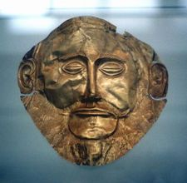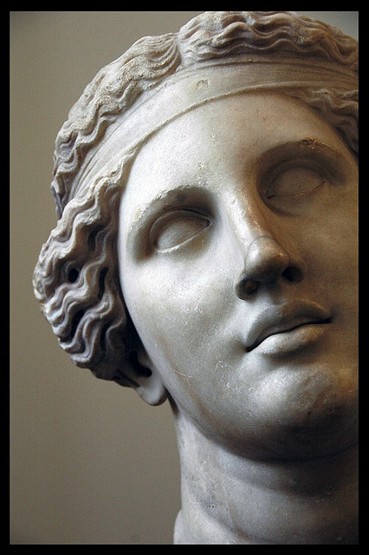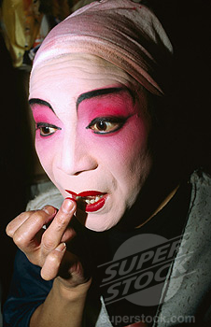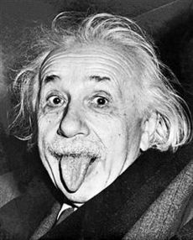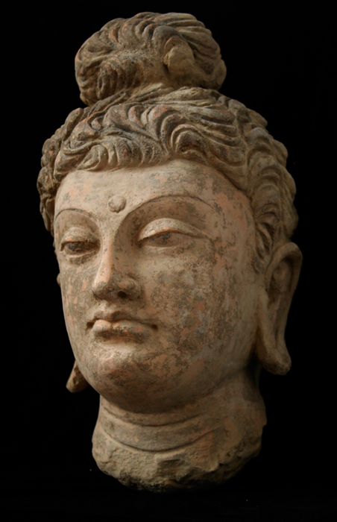

Other possible capabilities
Game-like activity: To identify faces, against a measure of accuracy as a clock record the period of time taken: see http://www.purposegames.com/game/192

Page 4. Faces of Encounter
Encountering other faces—including the non-human

—Registered people would be invited to upload images of humans in face-to-face encounter with others in the non-human world from animals to inanimate objects.
—Registered people would be invited to write about the emotions involved in the encounter, both in relation to how they themselves feel and how they think the people depicted feel.

5. Faces of Reconciliation
Images of people in relation across the boundaries of cultural and political difference

—Registered people would be invited to upload images of people in face-to-face encounter with other people across boundaries usually associated with cultural and political division: black and white; Jew and Arab, Bosnian and Serb, Brahman and Untouchable, etc.
—Registered people would be invited to write about the emotions involved in the encounter, both in relation to how they themselves feel and how they think the people depicted feel.

6. Clouds of Emotion
Taxonomies of emotions, passions, sins, and other human expressions, from across human history

This page would list, elaborate upon and analyze different taxonomies of human ‘emotions’ across world history and across different cultural settings

Websites
http://171.67.193.20/entries/emotions-17th18th/LD1Background.html#Aqu
—Standford Encyclopedia of Philosophy—long discussion of theories and lists of emotions

http://www.scribd.com/doc/3850260/Map-of-the-Emotions

Appendix 1. 500 faces

Relevant websites
http://www.bbc.co.uk/history/historic_figures/
—long list of names and biographies
http://www.webdesignerdepot.com/2009/06/100-portraits-of-iconic-people-of-all-time/
—beautiful photographs

http://www.dlmark.net/hundred.htm
The 100: A Ranking of the Most Influential Persons in History by Michael H. Hart
Contains biographies of all the following people, ranked in order from most influential to less influential, along with the author's reasons for so ranking them.
� Muhammad � Isaac Newton � Jesus Christ � Buddha � Confucius � St. Paul � Ts'ai Lun � Johann Gutenberg � Christopher Columbus � Albert Einstein � Louis Pasteur � Galileo Galilei � Aristotle � Euclid � Moses � Charles Darwin � Shih Huang Ti � Augustus Caesar � Nicolaus Copernicus � Antoine Laurent Lavoisier � Constantine the Great � James Watt � Michael Faraday � James Clerk Maxwell � Martin Luther � George Washington � Karl Marx � Orville and Wilbur Wright � Genghis Kahn � Adam Smith � Edward de Vere � John Dalton � Alexander the Great � Napoleon Bonaparte � Thomas Edison � Antony van Leeuwenhoek � William T.G. Morton � Guglielmo Marconi � Adolf Hitler � Plato � Oliver Cromwell � Alexander Graham Bell � Alexander Fleming � John Locke � Ludwig van Beethoven � Werner Heisenberg � Louis Daguerre � Simon Bolivar � Rene Descartes � Michelangelo � Pope Urban II � 'Umar ibn al-Khattab � Asoka � St. Augustine � William Harvey � Ernest Rutherford � John Calvin � Gregor Mendel � Max Planck � Joseph Lister � Nikolaus August Otto � Francisco Pizarro � Hernando Cortes � Thomas Jefferson � Queen Isabella I � Joseph Stalin � Julius Caesar � William the Conqueror � Sigmund Freud � Edward Jenner � Wilhelm Conrad Roentgen � Johann Sebastian Bach � Lao Tzu � Voltaire � Johannes Kepler � Enrico Fermi � Leonhard Euler � Jean-Jacques Rousseau � Nicoli Machiavelli � Thomas Malthus � John F. Kennedy � Gregory Pincus � Mani � Lenin � Sui Wen Ti � Vasco da Gama � Cyrus the Great � Peter the Great � Mao Zedong � Francis Bacon � Henry Ford � Mencius � Zoroaster � Queen Elizabeth I � Mikhail Gorbachev � Menes � Charlemagne � Homer � Justinian I � Mahavira �

Appendix 2

We have chosen 7 questions simply because we are treating ‘the number 7’ as an elegant framing number which has been used historically in many traditions as giving a complex of a cosmological whole. There are other relational issues around which we could have chosen further questions: solidarity, integration, reciprocity, etc.
This then has the same form as the ‘Circles of Sustainability’ method that has been used as an orienting method for choosing the 500 faces.

